import numpy as np
from osgeo import gdal
import matplotlib.pyplot as plt
import os

os. chdir(r'E:\CTECH\GEOINT\project')
file_name= 'SentinelTinkitamAPR2021.tif'
raster_info=gdal.Info(file_name,format='JSON')
print(raster_info)

Driver: GTiff/GeoTIFF
Files: SentinelTinkitamAPR2021.tif
Size is 176, 112
Coordinate System is:
PROJCRS["WGS 84 / UTM zone 45N",
BASEGEOGCRS["WGS 84",
DATUM["World Geodetic System 1984",
ELLIPSOID["WGS 84",6378137,298.257223563,
LENGTHUNIT["metre",1]]],
PRIMEM["Greenwich",0,
ANGLEUNIT["degree",0.0174532925199433]],
ID["EPSG",4326]],
CONVERSION["UTM zone 45N",
METHOD["Transverse Mercator",
ID["EPSG",9807]],
PARAMETER["Latitude of natural origin",0,
ANGLEUNIT["degree",0.0174532925199433],
ID["EPSG",8801]],
PARAMETER["Longitude of natural origin",87,
ANGLEUNIT["degree",0.0174532925199433],
ID["EPSG",8802]],
PARAMETER["Scale factor at natural origin",0.9996,
SCALEUNIT["unity",1],
ID["EPSG",8805]],
PARAMETER["False easting",500000,
LENGTHUNIT["metre",1],
ID["EPSG",8806]],
PARAMETER["False northing",0,
LENGTHUNIT["metre",1],
ID["EPSG",8807]]],
CS[Cartesian,2],
AXIS["(E)",east,
ORDER[1],
LENGTHUNIT["metre",1]],
AXIS["(N)",north,
ORDER[2],
LENGTHUNIT["metre",1]],
USAGE[
SCOPE["Navigation and medium accuracy spatial referencing."],
AREA["Between 84°E and 90°E, northern hemisphere between equator and 84°N, onshore and offshore. Bangladesh. Bhutan. China. India. Kazakhstan. Mongolia. Nepal. Russian Federation."],
BBOX[0,84,84,90]],
ID["EPSG",32645]]
Data axis to CRS axis mapping: 1,2
Origin = (633350.000000000000000,3012990.000000000000000)
Pixel Size = (10.000000000000000,-10.000000000000000)
Metadata:
AREA_OR_POINT=Area
Image Structure Metadata:
COMPRESSION=LZW
INTERLEAVE=PIXEL
Corner Coordinates:
Upper Left ( 633350.000, 3012990.000) ( 88d20'48.36"E, 27d13'59.78"N)
Lower Left ( 633350.000, 3011870.000) ( 88d20'47.92"E, 27d13'23.39"N)
Upper Right ( 635110.000, 3012990.000) ( 88d21'52.33"E, 27d13'59.16"N)
Lower Right ( 635110.000, 3011870.000) ( 88d21'51.89"E, 27d13'22.77"N)
Center ( 634230.000, 3012430.000) ( 88d21'20.12"E, 27d13'41.28"N)
Band 1 Block=256x256 Type=UInt16, ColorInterp=Gray
Description = B2
Band 2 Block=256x256 Type=UInt16, ColorInterp=Undefined
Description = B3
Band 3 Block=256x256 Type=UInt16, ColorInterp=Undefined
Description = B4
Band 4 Block=256x256 Type=UInt16, ColorInterp=Undefined
Description = B5
Band 5 Block=256x256 Type=UInt16, ColorInterp=Undefined
Description = B6
Band 6 Block=256x256 Type=UInt16, ColorInterp=Undefined
Description = B7
Band 7 Block=256x256 Type=UInt16, ColorInterp=Undefined
Description = B8
Band 8 Block=256x256 Type=UInt16, ColorInterp=Undefined
Description = B8A
Band 9 Block=256x256 Type=UInt16, ColorInterp=Undefined
Description = B11
Band 10 Block=256x256 Type=UInt16, ColorInterp=Undefined
Description = B12

from osgeo import gdal
import os

os. chdir(r'E:\CTECH\GEOINT\project')
file_name= 'SentinelTinkitamAPR2021.tif'
ds= gdal.Open(file_name)
print('File List:', ds.GetFileList())
print('width:', ds.RasterXSize)
print('height:', ds.RasterYSize)

print(ds)

File List: ['SentinelTinkitamAPR2021.tif']
width: 176
height: 112
<osgeo.gdal.Dataset; proxy of <Swig Object of type 'GDALDatasetShadow *' at 0x000001F46B750330> >

gt= ds.GetGeoTransform()
print('Origin:',(gt[0],gt[3]))
print('pixelsize:', gt[1],gt[5])

Origin: (633350.0, 3012990.0)
pixelsize: 10.0 -10.0

from osgeo import gdal
import os

os. chdir(r'E:\CTECH\GEOINT\project')
file_name= 'SentinelTinkitamAPR2021.tif'
ds= gdal.Open(file_name)

band = ds.GetRasterBand(1)
data = band.ReadAsArray()
print(data)
[[791 771 861 ... 427 400 378]
[839 825 818 ... 432 417 396]
[798 857 836 ... 419 417 413]
...
[416 429 402 ... 803 796 764]
[391 400 440 ... 828 771 728]
[456 427 456 ... 834 771 753]]

import matplotlib.pyplot as plt

plt.figure(figsize=(10,10))
plt.imshow(data,cmap= 'gray')

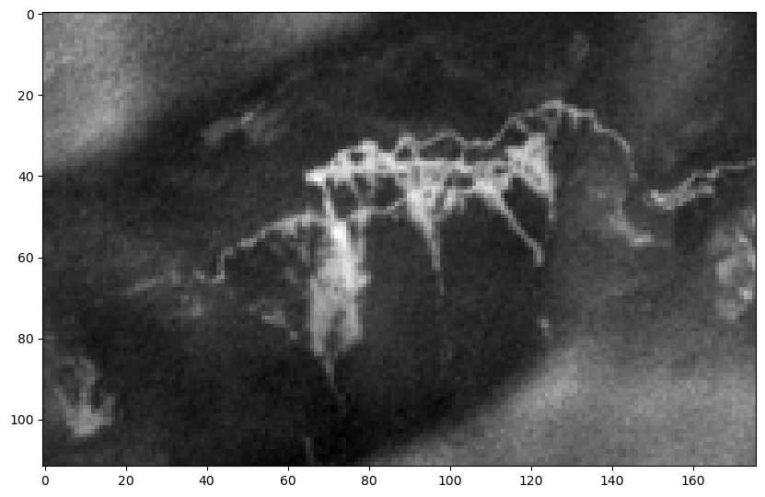

import matplotlib.pyplot as plt

plt.figure(figsize=(30,10)) #L=30, W=10
for i in range(1, ds.RasterCount+1):
band = ds.GetRasterBand(i)
data = band.ReadAsArray()

plt.subplot(2,5,i) #2 rows 5 col
plt.title('Band:'+str(i+1))
plt.imshow(data,cmap= 'gray')
plt.tight_layout()

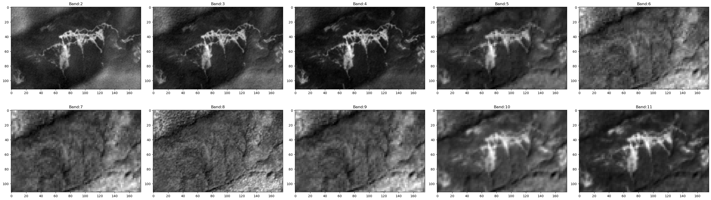

multidata = ds.ReadAsArray(band_list=[3,2,1])
multidata[2]

array([[791, 771, 861, ..., 427, 400, 378],
[839, 825, 818, ..., 432, 417, 396],
[798, 857, 836, ..., 419, 417, 413],
...,
[416, 429, 402, ..., 803, 796, 764],
[391, 400, 440, ..., 828, 771, 728],
[456, 427, 456, ..., 834, 771, 753]],
shape=(112, 176), dtype=uint16)

import numpy as np
multidata = ds.ReadAsArray(band_list=[7,3,2])
multidata = multidata.astype('float')
multidata/=np.max(multidata)

multidata = np.transpose(multidata, axes=(1,2,0))

plt.figure(figsize=(10,10))
plt.title('Band:')
plt.imshow(multidata)

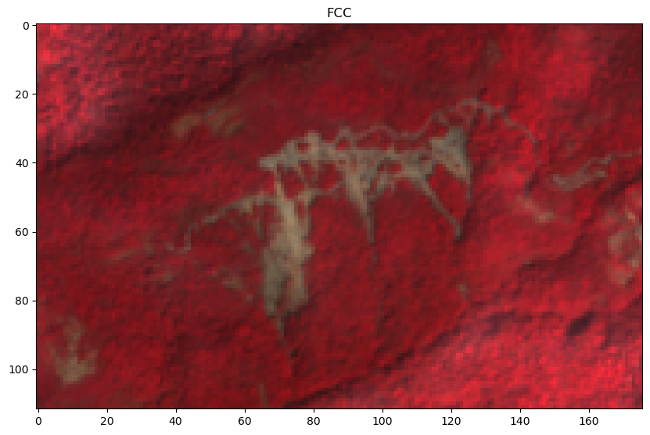

import numpy as np
import matplotlib.pyplot as plt
from osgeo import gdal

# Define file path
image_path = "E:\CTECH\GEOINT\project\SentinelTinkitamAPR2021.tif" # Replace with your actual path

# Open image using GDAL
dataset = gdal.Open(image_path)

# Select bands for FCC (False Color Composite)
# Example: Sentinel-2 Bands (NIR = 8, Red = 4, Green = 3)
nir_band = dataset.GetRasterBand(7).ReadAsArray().astype(np.float32)
red_band = dataset.GetRasterBand(3).ReadAsArray().astype(np.float32)
green_band = dataset.GetRasterBand(2).ReadAsArray().astype(np.float32)

# Normalize bands to 0-1 for visualization
nir_norm = (nir_band - nir_band.min()) / (nir_band.max() - nir_band.min())
red_norm = (red_band - red_band.min()) / (red_band.max() - red_band.min())
green_norm = (green_band - green_band.min()) / (green_band.max() - green_band.min())

# Stack bands to create FCC image (NIR-Red-Green)
fcc_image = np.dstack((nir_norm, red_norm, green_norm))

# Select a point for spectral analysis (row, column)
row, col = 60, 70 # Modify as needed

# Read all bands at the selected pixel location
spectral_values = []
wavelengths = [490, 560, 665, 705, 740, 783, 842, 865, 945, 1610, 2190] # Example Sentinel-2 Wavelengths

for band_index in range(1, dataset.RasterCount + 1):
band_data = dataset.GetRasterBand(band_index).ReadAsArray()
spectral_values.append(band_data[row, col])

# Convert spectral values to NumPy array
spectral_values = np.array(spectral_values)

# Display FCC image and Spectral Curve
fig, ax = plt.subplots(1, 2, figsize=(14, 6))

# Display False Color Composite (FCC)
ax[0].imshow(fcc_image)
ax[0].set_title("False Color Composite (NIR-Red-Green)")

# Display Spectral Curve
ax[1].plot(wavelengths[:len(spectral_values)], spectral_values, marker="o", linestyle="-", color="red")
ax[1].set_xlabel("Wavelength (nm)")
ax[1].set_ylabel("Reflectance")
ax[1].set_title(f"Spectral Curve at Pixel ({row}, {col})")
ax[1].grid(True)

plt.show()

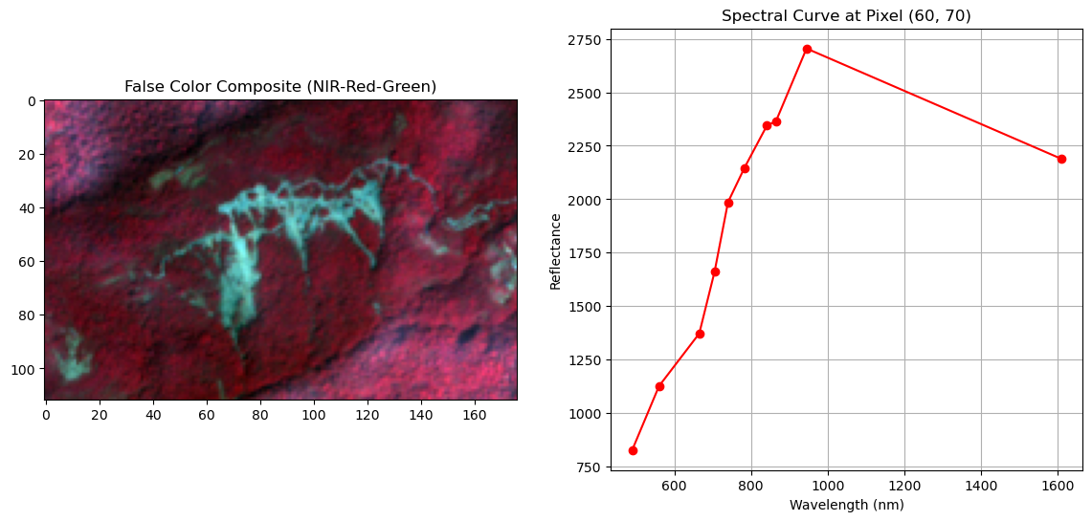

import numpy as np
import matplotlib.pyplot as plt
from osgeo import gdal

# Define file path
image_path = "E:\CTECH\GEOINT\project\SentinelTinkitamAPR2021.tif" # Replace with your actual image path

# Open image using GDAL
dataset = gdal.Open(image_path)

# Select bands for FCC (False Color Composite) - Sentinel-2 Example
# NIR (Band 8), Red (Band 4), Green (Band 3)
nir_band = dataset.GetRasterBand(7).ReadAsArray().astype(np.float32)
red_band = dataset.GetRasterBand(3).ReadAsArray().astype(np.float32)
green_band = dataset.GetRasterBand(2).ReadAsArray().astype(np.float32)

# Normalize bands to 0-1 for display
nir_norm = (nir_band - nir_band.min()) / (nir_band.max() - nir_band.min())
red_norm = (red_band - red_band.min()) / (red_band.max() - red_band.min())
green_norm = (green_band - green_band.min()) / (green_band.max() - green_band.min())

# Create FCC image (NIR-Red-Green)
fcc_image = np.dstack((nir_norm, red_norm, green_norm))

# Define multiple points for spectral analysis (row, col)
selected_points = {
"Vegetation": (30, 30),
"Landslide": (70, 70),

}

colors = {
"Vegetation": "green",
"Landslide": "red"
}

# Sentinel-2 Wavelengths (Example)
wavelengths = [490, 560, 665, 705, 740, 783, 842, 865, 945, 1610, 2190]

# Extract spectral values for selected points
spectral_curves = {}

for label, (row, col) in selected_points.items():
spectral_values = []

# Read all bands at the selected pixel location
for band_index in range(1, dataset.RasterCount + 1):
band_data = dataset.GetRasterBand(band_index).ReadAsArray()
spectral_values.append(band_data[row, col])

spectral_curves[label] = np.array(spectral_values)

# Display FCC Image & Spectral Curves
fig, ax = plt.subplots(1, 2, figsize=(14, 6))

# Display False Color Composite (FCC)
ax[0].imshow(fcc_image)
ax[0].set_title("False Color Composite (NIR-Red-Green)")

# Overlay selected points on FCC image
for label, (row, col) in selected_points.items():
ax[0].scatter(col, row, marker="o", color=colors[label], edgecolors="black", linewidth=1.5)

ax[0].legend()

# Display Spectral Curves for Multiple Points
for label, values in spectral_curves.items():
ax[1].plot(wavelengths[:len(values)], values, marker="o", linestyle="-", color=colors[label])

ax[1].set_xlabel("Wavelength (nm)")
ax[1].set_ylabel("Reflectance")
ax[1].set_title("Spectral Curves for Selected Points")
ax[1].legend()
ax[1].grid(True)

plt.show()

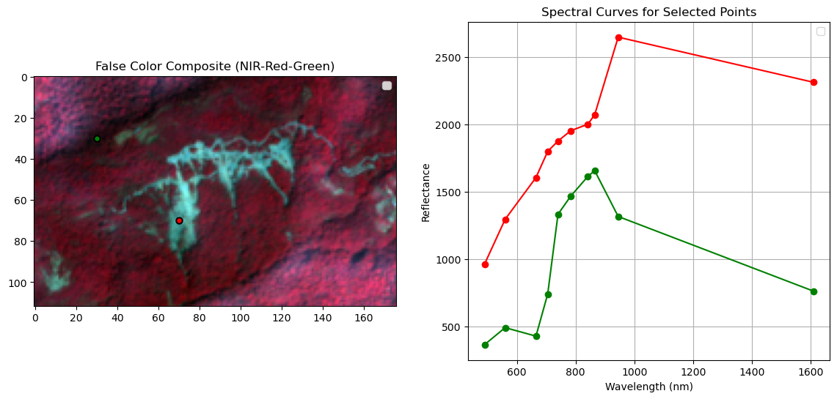

from osgeo import gdal
import numpy as np
import matplotlib.pyplot as plt

# Define file path
image_path = "E:\CTECH\GEOINT\project\SentinelTinkitamAPR2021.tif" # Replace with actual image path

# Open the image using GDAL
dataset = gdal.Open(image_path)

# Select band (Modify based on your dataset)
band_index = 3 # Example: Red Band (Sentinel-2)

# Read band as a NumPy array
band = dataset.GetRasterBand(band_index).ReadAsArray().astype('float32')

# Perform histogram equalization using NumPy
hist, bins = np.histogram(band.flatten(), bins=4096, range=[0,4096])
cdf = hist.cumsum() # Compute the cumulative distribution function
cdf_normalized = (cdf - cdf.min()) * 4095 / (cdf.max() - cdf.min()) # Normalize CDF
equalized_band = np.interp(band.flatten(), bins[:-1], cdf_normalized).reshape(band.shape).astype('float32')

# Display Original and Equalized Image
fig, ax = plt.subplots(1, 2, figsize=(12, 6))

ax[0].imshow(band, cmap='gray')
ax[0].set_title(f"Original Band {band_index}")
ax[0].axis("off")

ax[1].imshow(equalized_band, cmap='gray')
ax[1].set_title(f"Histogram Equalized Band {band_index}")
ax[1].axis("off")

plt.show()
print(image)
print(equalized_band)

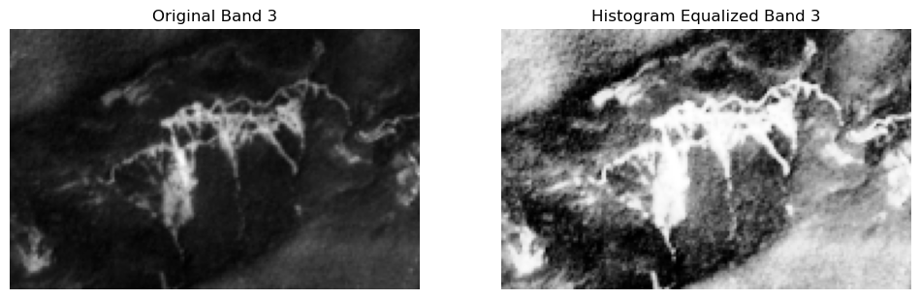

[[817. 839. 895. ... 470. 451. 446.]
[821. 799. 800. ... 481. 459. 478.]
[852. 797. 742. ... 464. 466. 448.]
...
[455. 489. 513. ... 850. 819. 742.]
[494. 539. 576. ... 815. 764. 676.]
[560. 578. 585. ... 840. 789. 663.]]
[[3400.1047 3485.071 3629.6592 ... 1040.7848 811.8537 751.8164 ]
[3417.555 3322.6172 3329.265 ... 1182.6722 904.7141 1140.9161 ]
[3519.764 3318.4624 3105.735 ... 964.95917 989.0572 776.74536]
...
[ 861.08844 1293.1907 1602.9332 ... 3515.8167 3409.2454 3105.735 ]
[1357.175 1901.4578 2225.119 ... 3392.003 3185.7156 2827.5693 ]
[2092.5798 2237.7913 2290.3499 ... 3486.9407 3284.6006 2769.6094 ]]

import numpy as np
import rasterio
import matplotlib.pyplot as plt
from osgeo import gdal

# Define file path
image_path = "E:\CTECH\GEOINT\project\SentinelTinkitamAPR2021.tif" # Replace with actual image path

# Open image using GDAL
dataset = gdal.Open(image_path)

# Select band (Modify based on your dataset)
band_index = 2 # Example: Red Band (Sentinel-2)

# Read band as a NumPy array
band = dataset.GetRasterBand(band_index).ReadAsArray().astype('float32')

# Extract DN frequency within a range
dn_min, dn_max = band.min(), band.max()
hist, bins = np.histogram(band.flatten(), bins=4096, range=[0, 4096])

# Compute Probability Density Function (PDF)
pdf = hist / np.sum(hist)

# Compute Cumulative Density Function (CDF)
cdf = pdf.cumsum()

# Normalize CDF to stretch pixel values between 0 and 255
cdf_normalized = (cdf - cdf.min()) * 4095 / (cdf.max() - cdf.min())

# Recalculate DN values using the CDF mapping
processed_band = np.interp(band.flatten(), bins[:-1], cdf_normalized).reshape(band.shape).astype('float32')

# Display Original, PDF, CDF, and Processed Image
fig, ax = plt.subplots(2, 3, figsize=(18, 10))

ax[0, 0].imshow(band, cmap='gray')
ax[0, 0].set_title(f"Original Band {band_index}")
ax[0, 0].axis("off")

ax[0, 1].bar(range(4096), hist, color='black')
ax[0, 1].set_title("DN Frequency Histogram")

ax[0, 2].plot(pdf, color='blue')
ax[0, 2].set_title("Probability Density Function (PDF)")

ax[1, 0].plot(cdf, color='red')
ax[1, 0].set_title("Cumulative Density Function (CDF)")

ax[1, 1].imshow(processed_band, cmap='gray')
ax[1, 1].set_title(f"Processed Band {band_index}")
ax[1, 1].axis("off")

ax[1, 2].bar(range(4096), np.histogram(processed_band.flatten(), bins=4096, range=[0, 4096])[0], color='black')
ax[1, 2].set_title("Processed DN Frequency")

plt.show()

print(image)
print(processed_band)

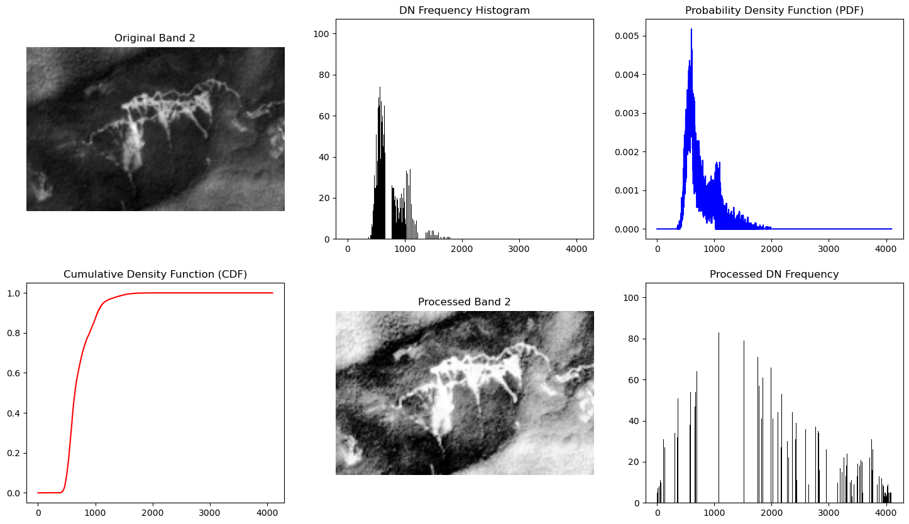
[[817. 839. 895. ... 470. 451. 446.]
[821. 799. 800. ... 481. 459. 478.]
[852. 797. 742. ... 464. 466. 448.]
...
[455. 489. 513. ... 850. 819. 742.]
[494. 539. 576. ... 815. 764. 676.]
[560. 578. 585. ... 840. 789. 663.]]
[[3675.3623 3825.9749 3870.0159 ... 444.7745 1079.4247 556.9549 ]
[3681.8022 3629.867 3651.6797 ... 662.6953 695.10297 518.10724]
[3681.8022 3552.7947 3492.342 ... 750.1545 902.0135 750.1545 ]
...
[ 976.5927 1365.4847 1544.9734 ... 3732.2834 3361.8804 3138.1428 ]
[1676.0582 1528.7695 1848.8992 ... 3535.76 3366.0352 3080.1829 ]
[2066.4045 2052.6936 2238.2068 ... 3513.5315 3368.3203 3361.8804 ]]

import numpy as np
import matplotlib.pyplot as plt
from scipy.ndimage import generic_filter
from osgeo import gdal

# Load image
image_path = "E:\CTECH\GEOINT\project\SentinelTinkitamAPR2021.tif"
dataset = gdal.Open(image_path)
image = dataset.GetRasterBand(7).ReadAsArray().astype(np.float32)

# Define Adaptive Filter (Local Mean & Variance)
def adaptive_filter(pixel_values):
"""
Adaptive filter function that reduces noise while preserving edges.
"""
local_mean = np.mean(pixel_values)
local_variance = np.var(pixel_values)

center_pixel = pixel_values[len(pixel_values) // 2]

# Noise variance (assumed)
noise_variance = 0.01

# Compute the adaptive filter coefficient
if local_variance > noise_variance:
weight = noise_variance / local_variance
else:
weight = 0 # Avoid division by zero

# Apply filter formula
filtered_pixel = center_pixel - weight * (center_pixel - local_mean)

return filtered_pixel

# Apply Adaptive Filter using a 5x5 kernel
filtered_image = generic_filter(image, adaptive_filter, size=(3, 3))

# Display Original and Filtered Images
fig, ax = plt.subplots(1, 2, figsize=(12, 6))

ax[0].imshow(image, cmap='gray')
ax[0].set_title("Original Image")
ax[0].axis("off")

ax[1].imshow(filtered_image, cmap='gray')
ax[1].set_title("Filtered Image (Adaptive)")
ax[1].axis("off")

plt.show()

print(image)

print(filtered_image)

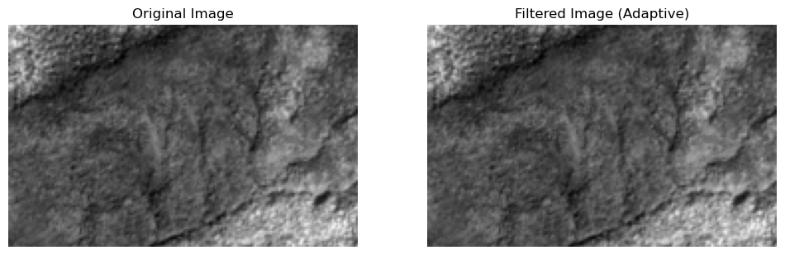
[[4012. 3812. 3758. ... 1626. 1966. 1856.]
[3760. 3363. 3164. ... 1664. 1876. 1892.]
[3475. 3024. 3040. ... 1860. 1924. 1836.]
...
[1701. 1790. 1808. ... 3012. 2033. 2032.]
[1772. 1740. 1830. ... 2661. 1983. 2503.]
[1912. 1884. 2025. ... 2729. 2430. 3105.]]
[[4012. 3812. 3758. ... 1626.0001 1965.9999 1856.0002]
[3760. 3363. 3164. ... 1664.0001 1876. 1891.9999]
[3475. 3024. 3040. ... 1860. 1924. 1836.0001]
...
[1701.0001 1790. 1808. ... 3012. 2033. 2032. ]
[1772. 1740.0001 1830. ... 2661. 1983. 2503. ]
[1911.9999 1884. 2025. ... 2729. 2430. 3105. ]]

import numpy as np
import matplotlib.pyplot as plt
from osgeo import gdal
from scipy.signal import convolve2d

# Load image
image_path = "E:\CTECH\GEOINT\project\SentinelTinkitamAPR2021.tif" # Replace with actual image path
dataset = gdal.Open(image_path)
image = dataset.GetRasterBand(1).ReadAsArray().astype(np.float32)

# Define a custom kernel (3x3 sharpening filter)
custom_kernel = np.array([
[ 0, -1, 0],
[-1, 5, -1],
[ 0, -1, 0]
], dtype=np.float32)

# Apply custom kernel using 2D convolution
filtered_image = convolve2d(image, custom_kernel, mode="same", boundary="symm")

# Display Original and Filtered Images
fig, ax = plt.subplots(1, 2, figsize=(12, 6))

ax[0].imshow(image, cmap='gray')
ax[0].set_title("Original Image")
ax[0].axis("off")

ax[1].imshow(filtered_image, cmap='gray')
ax[1].set_title("Filtered Image (Custom Kernel)")
ax[1].axis("off")

plt.show()

# Close dataset
dataset = None
print(image)
print(filtered_image)

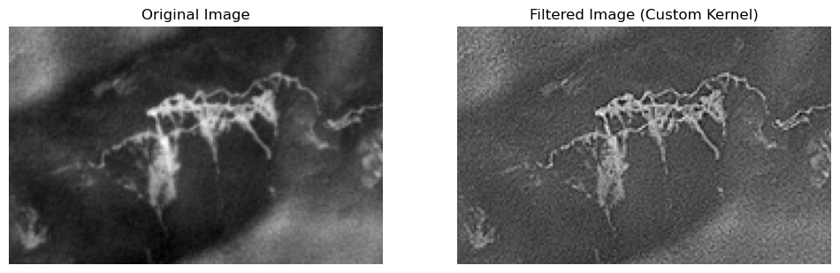

[[791. 771. 861. ... 427. 400. 378.]
[839. 825. 818. ... 432. 417. 396.]
[798. 857. 836. ... 419. 417. 413.]
...
[416. 429. 402. ... 803. 796. 764.]
[391. 400. 440. ... 828. 771. 728.]
[456. 427. 456. ... 834. 771. 753.]]
[[ 763. 607. 1028. ... 454. 378. 338.]
[ 942. 840. 714. ... 448. 440. 376.]
[ 655. 1059. 921. ... 370. 445. 476.]
...
[ 391. 477. 315. ... 822. 862. 747.]
[ 292. 313. 497. ... 907. 732. 624.]
[ 550. 396. 532. ... 992. 726. 760.]]

import numpy as np
import matplotlib.pyplot as plt
from osgeo import gdal
from scipy.signal import convolve2d

# Load image
image_path = "E:\CTECH\GEOINT\project\SentinelTinkitamAPR2021.tif" # Replace with actual image path
dataset = gdal.Open(image_path)
image = dataset.GetRasterBand(1).ReadAsArray().astype(np.float32)

# Define a custom kernel (3x3 sharpening filter)
custom_kernel = np.array([
[-1, -1, -1],
[-1, 16, -1],
[-1, -1, -1]
], dtype=np.float32)

# Apply custom kernel using 2D convolution
filtered_image = convolve2d(image, custom_kernel, mode="same", boundary="symm")

# Display Original and Filtered Images
fig, ax = plt.subplots(1, 2, figsize=(12, 6))

ax[0].imshow(image, cmap='gray')
ax[0].set_title("Original Image")
ax[0].axis("off")

ax[1].imshow(filtered_image, cmap='gray')
ax[1].set_title("Filtered Image (high pass)")
ax[1].axis("off")

plt.show()

# Close dataset
dataset = None
print(image)
print(filtered_image)

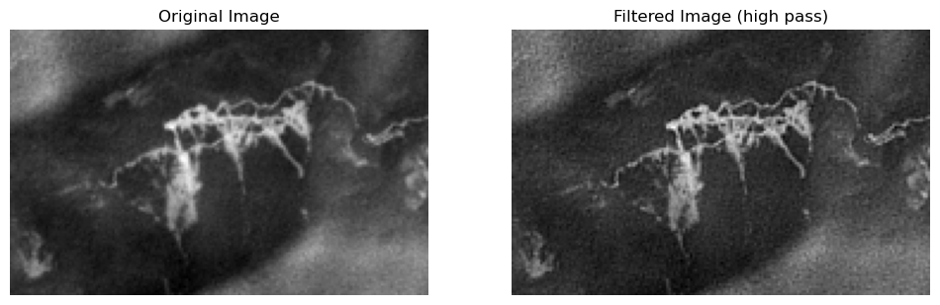

import numpy as np
import matplotlib.pyplot as plt
from osgeo import gdal
from scipy.signal import convolve2d

# Load image
image_path = "E:\CTECH\GEOINT\project\SentinelTinkitamAPR2021.tif" # Replace with actual image path
dataset = gdal.Open(image_path)
image = dataset.GetRasterBand(3).ReadAsArray().astype(np.float32)

# Define a custom kernel (3x3 sharpening filter)
custom_kernel = np.array([
[1, 0, -1],
[2, 0, -2],
[1, 0, -1]
], dtype=np.float32)

# Apply custom kernel using 2D convolution
filtered_image = convolve2d(image, custom_kernel, mode="same", boundary="symm")

# Display Original and Filtered Images
fig, ax = plt.subplots(1, 2, figsize=(12, 6))

ax[0].imshow(image, cmap='gray')
ax[0].set_title("Original Image")
ax[0].axis("off")

ax[1].imshow(filtered_image, cmap='Greens')
ax[1].set_title("Filtered Image (sobel)")
ax[1].axis("off")

plt.show()

# Close dataset
dataset = None
print(image)
print(filtered_image)

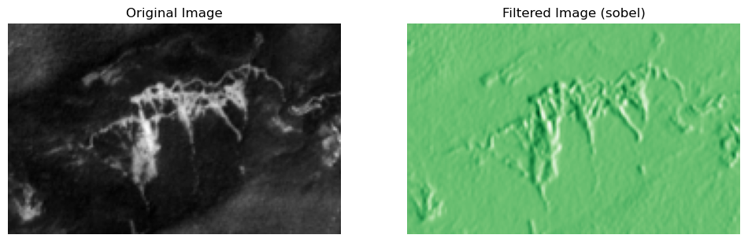
[[817. 839. 895. ... 470. 451. 446.]
[821. 799. 800. ... 481. 459. 478.]
[852. 797. 742. ... 464. 466. 448.]
...
[455. 489. 513. ... 850. 819. 742.]
[494. 539. 576. ... 815. 764. 676.]
[560. 578. 585. ... 840. 789. 663.]]
[[ 44. 213. -60. ... -158. -75. 4.]
[ -77. -74. -84. ... -108. -46. 15.]
[-175. -361. -154. ... -58. -81. -39.]
...
[ 95. 182. 48. ... -57. -489. -363.]
[ 142. 247. 45. ... -244. -563. -379.]
[ 99. 157. 27. ... -348. -670. -466.]]
from osgeo import gdal
import numpy as np
import matplotlib.pyplot as plt

# Define file path
image_path = "E:\CTECH\GEOINT\project\SentinelTinkitamAPR2021.tif" # Near-Infrared band (Band 8 for Sentinel-2)

# Open image
dataset = gdal.Open(image_path)

# Select bands (modify based on your dataset)
band1_index = 8 # Example: Near-Infrared (NIR) Band
band2_index = 4 # Example: Red Band

# Read bands as arrays
band1 = dataset.GetRasterBand(band1_index).ReadAsArray().astype(np.float32)
band2 = dataset.GetRasterBand(band2_index).ReadAsArray().astype(np.float32)

# Apply subtraction: Band1 - Band2
subtracted_image = band1 - band2

# Display Original Bands and Subtracted Image
fig, ax = plt.subplots(1, 3, figsize=(15, 5))

ax[0].imshow(band1, cmap='gray')
ax[0].set_title(f"Band {band1_index} (NIR)")
ax[0].axis("off")

ax[1].imshow(band2, cmap='gray')
ax[1].set_title(f"Band {band2_index} (Red)")
ax[1].axis("off")

ax[2].imshow(subtracted_image, cmap='gray')
ax[2].set_title("Band Subtraction (Band1 - Band2)")
ax[2].axis("off")

plt.show()

print(band1)
print(band2)
print (subtracted_image)

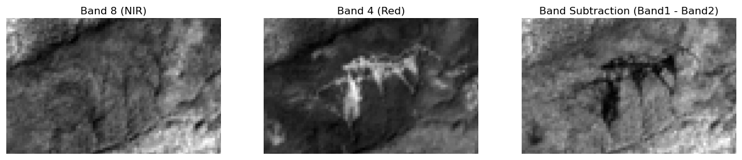
[[3772. 3719. 3719. ... 1891. 1891. 1999.]
[3835. 3508. 3508. ... 1987. 1987. 1966.]
[3835. 3508. 3508. ... 1987. 1987. 1966.]
...
[1959. 1951. 1951. ... 2541. 2541. 3017.]
[1959. 1951. 1951. ... 2541. 2541. 3017.]
[2060. 2180. 2180. ... 2777. 2777. 3635.]]
[[1637. 1516. 1516. ... 797. 797. 779.]
[1566. 1442. 1442. ... 883. 883. 855.]
[1566. 1442. 1442. ... 883. 883. 855.]
...
[ 868. 930. 930. ... 1222. 1222. 1139.]
[ 868. 930. 930. ... 1222. 1222. 1139.]
[ 944. 1035. 1035. ... 1183. 1183. 1283.]]
[[2135. 2203. 2203. ... 1094. 1094. 1220.]
[2269. 2066. 2066. ... 1104. 1104. 1111.]
[2269. 2066. 2066. ... 1104. 1104. 1111.]
...
[1091. 1021. 1021. ... 1319. 1319. 1878.]
[1091. 1021. 1021. ... 1319. 1319. 1878.]
[1116. 1145. 1145. ... 1594. 1594. 2352.]]

from osgeo import gdal
import numpy as np
import matplotlib.pyplot as plt

# Define file paths

image_path = "E:\CTECH\GEOINT\project\SentinelTinkitamAPR2021.tif" # Near-Infrared band (Band 8 for Sentinel-2)

# Open the NIR and Red bands
image_dataset = gdal.Open(image_path)

# Read data as arrays
nir_band = image_dataset.GetRasterBand(7).ReadAsArray().astype('float')
red_band = image_dataset.GetRasterBand(3).ReadAsArray().astype('float')

# Compute NDVI
ndvi = (nir_band - red_band) / (nir_band + red_band ) # Adding a small value to avoid division by zero

print(ndvi)

def classify_ndvi(ndvi_array):
"""
Classifies NDVI values into categories.
"""
ndvi_class = np.zeros_like(ndvi_array, dtype=np.uint8)

# Define NDVI classes
ndvi_class[(ndvi_array <= -1.0)] = 1 # No data
ndvi_class[(ndvi_array > -1.0) & (ndvi_array < 0.0)] = 1 # Water
ndvi_class[(ndvi_array >= 0.0) & (ndvi_array < 0.2)] = 1 # Barren land (rock, sand, snow)
ndvi_class[(ndvi_array >= 0.2) & (ndvi_array < 0.4)] = 1 # Sparse vegetation
ndvi_class[(ndvi_array >= 0.4) & (ndvi_array < 0.6)] = 0 # Moderate vegetation
ndvi_class[(ndvi_array >= 0.6) & (ndvi_array <= 1.0)] = 0 # Dense vegetation

return ndvi_class

# Apply classification
ndvi_classes = classify_ndvi(ndvi)

plt.figure(figsize=(10, 6))
plt.imshow(ndvi, cmap='RdYlGn') # Red-Yellow-Green colormap
plt.colorbar(label="NDVI Value")
plt.title("NDVI Visualization")
plt.axis("off") # Hide axis
plt.show()

fig, ax = plt.subplots(1,2,figsize=(15, 10))

ax[0].imshow(ndvi, cmap='RdYlGn')
ax[0].set_title('NDVI')

ax[1].imshow(ndvi_classes, cmap='Greens')
ax[1].set_title('NDVI Zone')

# Save NDVI output
'''driver = gdal.GetDriverByName("GTiff")
ndvi_dataset = driver.Create(ndvi_output_path, red_dataset.RasterXSize, red_dataset.RasterYSize, 1, gdal.GDT_Float32)
ndvi_dataset.SetGeoTransform(red_dataset.GetGeoTransform()) # Copy georeferencing
ndvi_dataset.SetProjection(red_dataset.GetProjection()) # Copy projection

ndvi_band = ndvi_dataset.GetRasterBand(1)
ndvi_band.WriteArray(ndvi)
ndvi_band.SetNoDataValue(-9999) # Set NoData value
ndvi_band.FlushCache()

# Close datasets
nir_dataset = None
red_dataset = None
ndvi_dataset = None

print(f"NDVI image saved at {ndvi_output_path}")'''

<>:7: SyntaxWarning: invalid escape sequence '\C'
<>:7: SyntaxWarning: invalid escape sequence '\C'
C:\Users\ghosh\AppData\Local\Temp\ipykernel_7120\645473656.py:7: SyntaxWarning: invalid escape sequence '\C'
image_path = "E:\CTECH\GEOINT\project\SentinelTinkitamAPR2021.tif" # Near-Infrared band (Band 8 for Sentinel-2)
[[0.66162767 0.63921737 0.61530196 ... 0.55152672 0.6268101 0.61251086]
[0.64156298 0.61604998 0.59636731 ... 0.55151515 0.60685225 0.59662447]
[0.60619367 0.58283172 0.60761502 ... 0.60068847 0.61004184 0.60770578]
...
[0.57792208 0.57086441 0.55794916 ... 0.55981357 0.4256662 0.46503244]
[0.56398941 0.52698552 0.52119701 ... 0.5310702 0.44375683 0.57470903]
[0.54692557 0.53046304 0.55172414 ... 0.52927991 0.50978565 0.64808917]]

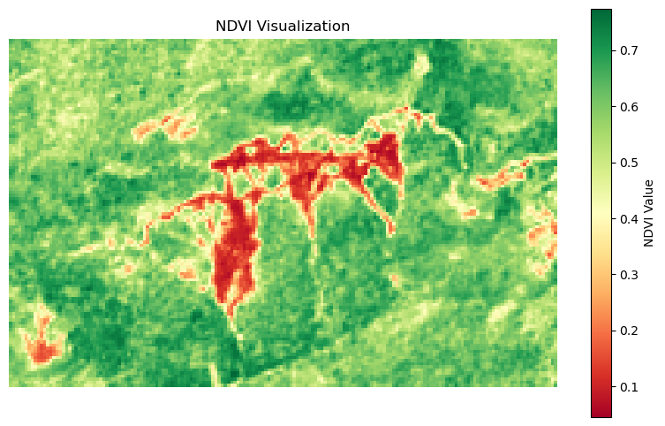
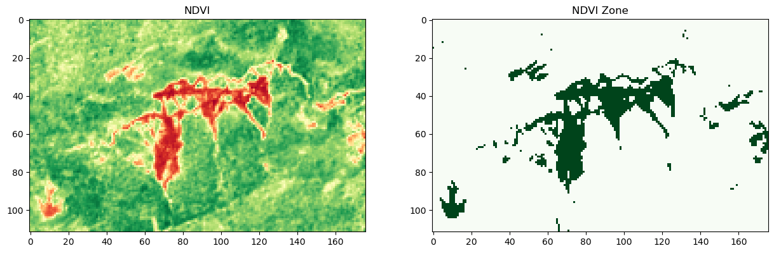

from osgeo import gdal
import matplotlib.pyplot as plt

# Open the image file
ds = gdal.Open(r'E:\CTECH\GEOINT\project\SentinelTinkitamAPR2021.tif')

# Get the number of bands in the image
num_bands = ds.RasterCount

# Create subplots for each band
fig, axs = plt.subplots(1, num_bands, figsize=(20, 20))

# Loop through each band and display it
for i in range(1, num_bands + 1):
band = ds.GetRasterBand(i).ReadAsArray()
axs[i - 1].imshow(band, cmap='gray') # You can choose any colormap here
axs[i - 1].set_title('Band {}'.format(i))

plt.show()

import rasterio
import matplotlib.pyplot as plt

# Load the multispectral image
img_path = r'E:\CTECH\GEOINT\project\SentinelTinkitamAPR2021.tif'
img = rasterio.open(img_path)

# Get individual bands
band2 = img.read(1)
band3 = img.read(2)
band4 = img.read(3)
band8 = img.read(7)

# Create subplots for each band
fig, axs = plt.subplots(1,2, figsize=(15, 10))

# Display Band 2
axs[0].imshow(band2, cmap='gray')
axs[0].set_title('Band 2')

# Display Band 3
axs[1].imshow(band3, cmap='gray')
axs[1].set_title('Band 3')

# Create subplots for each band
fig, axs1 = plt.subplots(1,2, figsize=(15, 10))

# Display Band 4
axs1[0].imshow(band4, cmap='gray')
axs1[0].set_title('Band 4')

# Display Band 8
axs1[1].imshow(band8, cmap='gray')
axs1[1].set_title('Band 8')

plt.show()

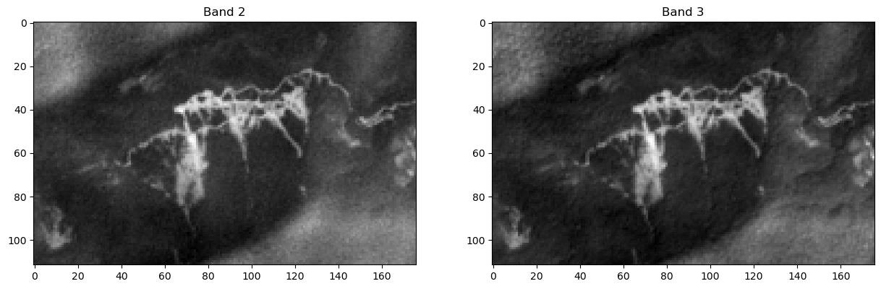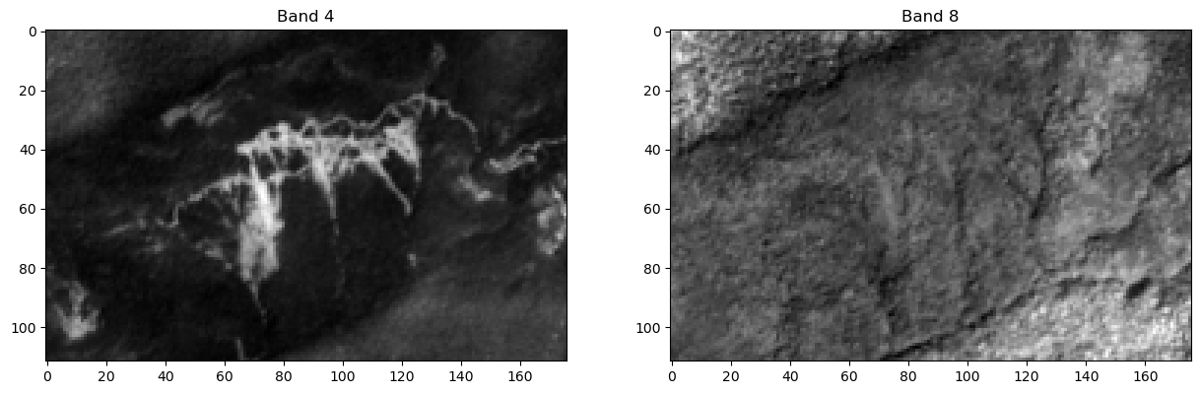

import rasterio

# Load the multispectral image
img_path = r'E:\CTECH\GEOINT\project\SentinelTinkitamAPR2021.tif'
img = rasterio.open(img_path)

print(img)
data = img.read(7) # as per specific band it is IR band 08 - denote by 7
#print(data)

num_bands = img.count
print('Number of bands in image: ', num_bands)

# row and column
rows, cols = img.shape
print('Image size is: {0} rows x {1} columns.'.format(rows, cols))

#min & max value for specific bands
min_value = data.min()
max_value = data.max()
print("Data minimum value: ", min_value)
print("Data maximum value: ", max_value)

<open DatasetReader name='E:\CTECH\GEOINT\project\SentinelTinkitamAPR2021.tif' mode='r'>
Number of bands in image: 10
Image size is: 112 rows x 176 columns.
Data minimum value: 987
Data maximum value: 4692
import rasterio
from rasterio.plot import show
import numpy as np
import matplotlib.pyplot as plt
import pandas as pd
import numpy as np
import imageio
import rasterio

# Load Sentinel data bands
sat_data = rasterio.open('E:\CTECH\GEOINT\project\SentinelTinkitamAPR2021.tif')

# Read the individual bands
blue_band = sat_data.read(1).astype('float32')
green_band = sat_data.read(2).astype('float32')
red_band = sat_data.read(3).astype('float32')
NIR_band = sat_data.read(7).astype('float32')

# Normalize data (optional)
blue_band /= np.max(blue_band)
green_band /= np.max(green_band)
red_band /= np.max(red_band)
NIR_band /= np.max(NIR_band)

truecolor = np.dstack((blue_band, green_band, red_band))
Falsecolor= np.dstack((NIR_band, red_band, green_band))

# Create subplots for each band
fig, axs1 = plt.subplots(1,2, figsize=(15, 10))

# Display Band 4
axs1[0].imshow(truecolor)
axs1[0].set_title('True color composite')

# Display Band 8
axs1[1].imshow(Falsecolor)
axs1[1].set_title('False color composite')

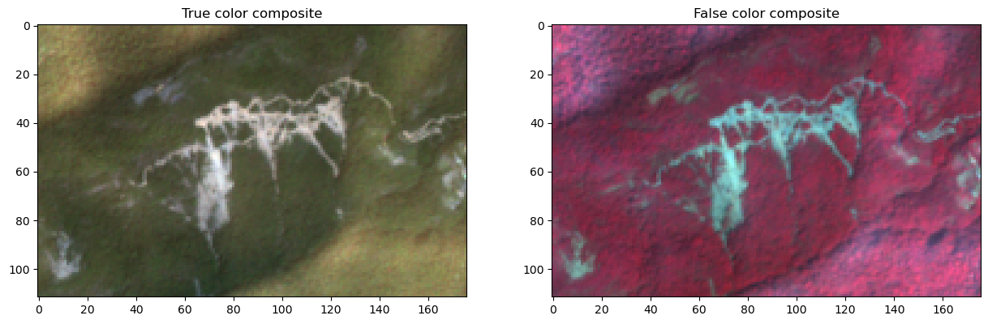

Extract the DN values of all bands – Export to excel

import pandas as pd
import numpy as np
import imageio
import rasterio
import openpyxl

ds = rasterio.open('E:\CTECH\GEOINT\project\SentinelTinkitamAPR2021.tif')

print("Band 2, Blue")
data_b = ds.read(1)
df_b=pd.DataFrame(data_b)
print(df_b)

print("-----------------------------------------------------")

print("Band 3, Green")
data_g = ds.read(2)
df_g=pd.DataFrame(data_g)
print(df_g)

print("-----------------------------------------------------")

print("Band 4, Red")
data_r = ds.read(3)
df_r=pd.DataFrame(data_r)
print(df_r)

print("-----------------------------------------------------")

print("Band 8, NIR")
data_nir = ds.read(4)
df_nir=pd.DataFrame(data_nir)
print(df_nir)

print("-----------------------------------------------------")

#save to Excel

file_path = "E:\CTECH\GEOINT\project\Landslide.xlsx"
excel_writer=pd.ExcelWriter(file_path, engine='openpyxl')

df_b.to_excel(excel_writer, sheet_name= 'Landslide2023 Blue')
df_g.to_excel(excel_writer, sheet_name= 'Landslide2023 Green')
df_r.to_excel(excel_writer, sheet_name= 'Landslide2023 Red')
df_nir.to_excel(excel_writer, sheet_name= 'Landslide2023 NIR')
excel_writer.close()

<>:7: SyntaxWarning: invalid escape sequence '\C'
<>:39: SyntaxWarning: invalid escape sequence '\C'
<>:7: SyntaxWarning: invalid escape sequence '\C'
<>:39: SyntaxWarning: invalid escape sequence '\C'
C:\Users\ghosh\AppData\Local\Temp\ipykernel_2600\3474106135.py:7: SyntaxWarning: invalid escape sequence '\C'
ds = rasterio.open('E:\CTECH\GEOINT\project\SentinelTinkitamAPR2021.tif')
C:\Users\ghosh\AppData\Local\Temp\ipykernel_2600\3474106135.py:39: SyntaxWarning: invalid escape sequence '\C'
file_path = "E:\CTECH\GEOINT\project\Landslide.xlsx"
Band 2, Blue
0 1 2 3 4 5 6 7 8 9 ... 166 167 168 \
0 791 771 861 827 914 902 897 918 948 942 ... 515 544 486
1 839 825 818 854 888 894 872 904 999 962 ... 563 561 472
2 798 857 836 793 851 892 856 932 893 879 ... 578 557 515
3 841 767 791 802 794 850 940 891 839 872 ... 589 540 518
4 814 767 799 864 818 839 888 868 919 906 ... 605 590 599
.. ... ... ... ... ... ... ... ... ... ... ... ... ... ...
107 453 433 425 412 398 417 433 424 402 416 ... 851 836 860
108 453 450 416 429 422 424 434 416 414 455 ... 882 857 835
109 416 429 402 410 470 461 453 474 511 494 ... 789 855 924
110 391 400 440 445 444 461 472 488 529 504 ... 849 857 861
111 456 427 456 425 427 410 441 442 459 491 ... 869 832 858

169 170 171 172 173 174 175
0 478 457 415 422 427 400 378
1 488 458 456 449 432 417 396
2 519 515 467 432 419 417 413
3 514 507 444 449 444 391 363
4 532 468 460 469 438 381 393
.. ... ... ... ... ... ... ...
107 835 862 855 849 891 813 772
108 802 827 846 808 802 780 785
109 888 860 822 767 803 796 764
110 885 834 821 825 828 771 728
111 904 877 787 745 834 771 753

[112 rows x 176 columns]
-----------------------------------------------------
Band 3, Green
0 1 2 3 4 5 6 7 8 9 ... 166 \
0 1034 1098 1126 1086 1148 1102 1048 1138 1214 1200 ... 617
1 1036 1019 1026 1042 1154 1136 1090 1178 1190 1098 ... 642
2 1036 995 975 950 1066 1072 1076 1136 1104 1020 ... 686
3 971 938 953 932 1062 1050 1082 1106 1074 1013 ... 712
4 1015 958 992 1026 1042 1030 1102 1102 1160 1096 ... 728
.. ... ... ... ... ... ... ... ... ... ... ... ...
107 576 589 583 548 591 575 628 633 631 613 ... 965
108 560 584 603 553 595 645 670 623 670 677 ... 1042
109 557 586 599 589 628 662 656 675 731 716 ... 961
110 608 598 623 641 639 638 619 639 704 689 ... 1012
111 645 644 666 677 638 626 605 640 641 634 ... 1056

167 168 169 170 171 172 173 174 175
0 668 650 594 555 544 550 509 565 521
1 647 624 640 592 568 562 531 534 517
2 714 646 679 632 611 538 539 551 539
3 724 713 684 658 615 565 623 542 551
4 750 711 654 602 578 589 579 515 507
.. ... ... ... ... ... ... ... ... ...
107 1023 993 1072 1108 1048 1042 1052 1013 947
108 1003 1021 1023 965 982 996 1028 969 874
109 1044 1104 1096 1064 1112 1102 1054 929 847
110 1066 1108 1070 1054 1078 1034 990 931 830
111 1074 1100 1122 1100 1042 996 983 932 929

[112 rows x 176 columns]
-----------------------------------------------------
Band 4, Red
0 1 2 3 4 5 6 7 8 9 ... 166 167 168 \
0 817 839 895 825 882 919 830 913 1000 953 ... 498 554 520
1 821 799 800 781 898 891 825 987 1056 908 ... 561 550 522
2 852 797 742 763 842 834 844 941 909 802 ... 592 588 562
3 862 819 742 751 823 863 882 870 800 828 ... 652 640 618
4 850 804 796 899 895 852 848 885 840 835 ... 650 660 659
.. ... ... ... ... ... ... ... ... ... ... ... ... ... ...
107 502 471 460 469 514 526 562 554 532 530 ... 855 824 772
108 497 479 481 469 524 518 530 556 551 582 ... 859 827 818
109 455 489 513 515 583 581 592 655 672 669 ... 786 819 886
110 494 539 576 545 563 629 622 633 719 724 ... 788 835 894
111 560 578 585 585 523 546 576 609 647 657 ... 830 838 846

169 170 171 172 173 174 175
0 500 463 451 493 470 451 446
1 495 511 489 491 481 459 478
2 566 568 497 468 464 466 448
3 569 568 502 484 486 462 440
4 561 583 516 500 487 431 437
.. ... ... ... ... ... ... ...
107 867 942 913 878 883 850 787
108 835 783 809 837 867 854 733
109 952 808 849 817 850 819 742
110 944 875 886 842 815 764 676
111 927 904 861 879 840 789 663

[112 rows x 176 columns]
-----------------------------------------------------
Band 8, NIR
0 1 2 3 4 5 6 7 8 9 ... 166 \
0 1637 1516 1516 1556 1556 1400 1400 1532 1532 1613 ... 858
1 1566 1442 1442 1483 1483 1501 1501 1581 1581 1378 ... 1020
2 1566 1442 1442 1483 1483 1501 1501 1581 1581 1378 ... 1020
3 1543 1333 1333 1453 1453 1436 1436 1484 1484 1417 ... 1059
4 1543 1333 1333 1453 1453 1436 1436 1484 1484 1417 ... 1059
.. ... ... ... ... ... ... ... ... ... ... ... ...
107 853 847 847 887 887 1014 1014 1033 1033 1007 ... 1391
108 853 847 847 887 887 1014 1014 1033 1033 1007 ... 1391
109 868 930 930 991 991 1046 1046 1083 1083 1079 ... 1402
110 868 930 930 991 991 1046 1046 1083 1083 1079 ... 1402
111 944 1035 1035 1047 1047 973 973 953 953 944 ... 1425

167 168 169 170 171 172 173 174 175
0 806 806 794 794 829 829 797 797 779
1 963 963 905 905 866 866 883 883 855
2 963 963 905 905 866 866 883 883 855
3 1048 1048 939 939 889 889 877 877 760
4 1048 1048 939 939 889 889 877 877 760
.. ... ... ... ... ... ... ... ... ...
107 1418 1418 1421 1421 1439 1439 1292 1292 1201
108 1418 1418 1421 1421 1439 1439 1292 1292 1201
109 1505 1505 1450 1450 1531 1531 1222 1222 1139
110 1505 1505 1450 1450 1531 1531 1222 1222 1139
111 1581 1581 1562 1562 1413 1413 1183 1183 1283

[112 rows x 176 columns]

#Subset image

import rasterio
from rasterio.plot import show
import numpy as np
import matplotlib.pyplot as plt
import pandas as pd
import imageio

# Load Sentinel data bands
sat_data = rasterio.open("E:\CTECH\GEOINT\project\SentinelTinkitamAPR2021.tif")

# Read the individual bands
blue_band_2 = sat_data.read(1)
green_band_3 = sat_data.read(2)
red_band_4 = sat_data.read(3)
rededge1_band_5 = sat_data.read(4)
rededge2_band_6 = sat_data.read(5)
rededge3_band_7 = sat_data.read(6)
NIR_band_8 = sat_data.read(7)
rededge4_band_8A = sat_data.read(8)
SWIR1_band_11 = sat_data.read(9)
SWIR2_band_12 = sat_data.read(10)

# Create a composite
composite = np.dstack((blue_band_2, green_band_3, red_band_4,rededge1_band_5, rededge2_band_6,rededge3_band_7, NIR_band_8, rededge4_band_8A, SWIR1_band_11, SWIR2_band_12))

truecolor = np.dstack((NIR_band_8, red_band_4, green_band_3, blue_band_2))
# Create a composite
subset = truecolor[20:30, 50:60] # y-Axis, X-Axis

# Save the subset image
imageio.imwrite('E:\CTECH\GEOINT\project\SubLandslide2021.tiff', subset)

<>:12: SyntaxWarning: invalid escape sequence '\C'
<>:34: SyntaxWarning: invalid escape sequence '\C'
<>:12: SyntaxWarning: invalid escape sequence '\C'
<>:34: SyntaxWarning: invalid escape sequence '\C'
C:\Users\ghosh\AppData\Local\Temp\ipykernel_8516\4174572581.py:12: SyntaxWarning: invalid escape sequence '\C'
sat_data = rasterio.open("E:\CTECH\GEOINT\project\SentinelTinkitamAPR2021.tif")
C:\Users\ghosh\AppData\Local\Temp\ipykernel_8516\4174572581.py:34: SyntaxWarning: invalid escape sequence '\C'
imageio.imwrite('E:\CTECH\GEOINT\project\SubLandslide2021.tiff', subset)

import rasterio
from rasterio.plot import show
import matplotlib.pyplot as plt
import numpy as np

# Open the satellite image
sat_data = rasterio.open('E:\CTECH\GEOINT\project\SubLandslide2021.tiff')

# Read the individual bands
blue_band_2 = sat_data.read(1)
green_band_3 = sat_data.read(2)
red_band_4 = sat_data.read(3)
NIR_band_8 = sat_data.read(4)

fig=plt.figure(dpi=300)

fig, ax = plt.subplots(figsize=(10,10))
ax.imshow(blue_band_2, cmap='gray')
plt.axis("off")
plt.title("Band 2, Blue")
for i in range(blue_band_2.shape[0]):
for j in range(blue_band_2.shape[1]):
ax.text(j,i, str(blue_band_2[i,j])),

fig, ax = plt.subplots(figsize=(10,10))
ax.imshow(green_band_3, cmap='gray')
plt.axis("off")
plt.title("Band 3, Green")
for i in range(green_band_3.shape[0]):
for j in range(green_band_3.shape[1]):
ax.text(j,i, str(green_band_3[i,j])),

fig, ax = plt.subplots(figsize=(10,10))
ax.imshow(red_band_4, cmap='gray')
for i in range(red_band_4.shape[0]):
for j in range(red_band_4.shape[1]):
ax.text(j,i, str(red_band_4[i,j])),
plt.axis("off")
plt.title("Band 4, Red")

fig, ax = plt.subplots(figsize=(10,10))
ax.imshow(NIR_band_8, cmap='gray')
for i in range(NIR_band_8.shape[0]):
for j in range(NIR_band_8.shape[1]):
ax.text(j,i, str(NIR_band_8[i,j])),
plt.axis("off")
plt.title("Band 8, NIR")

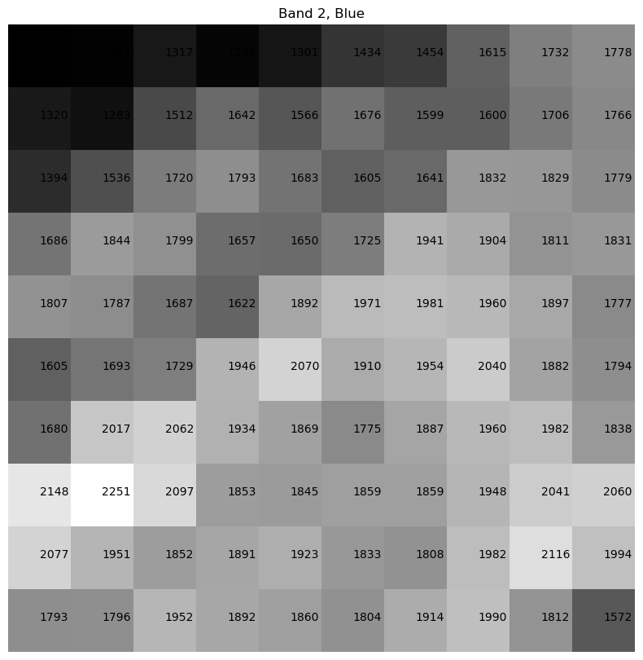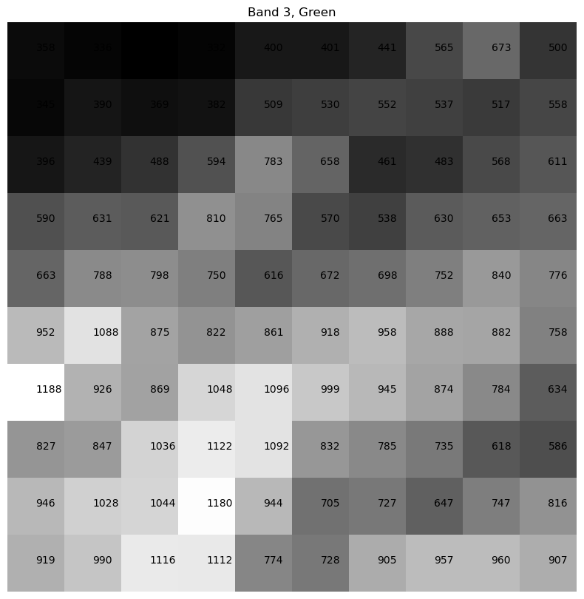
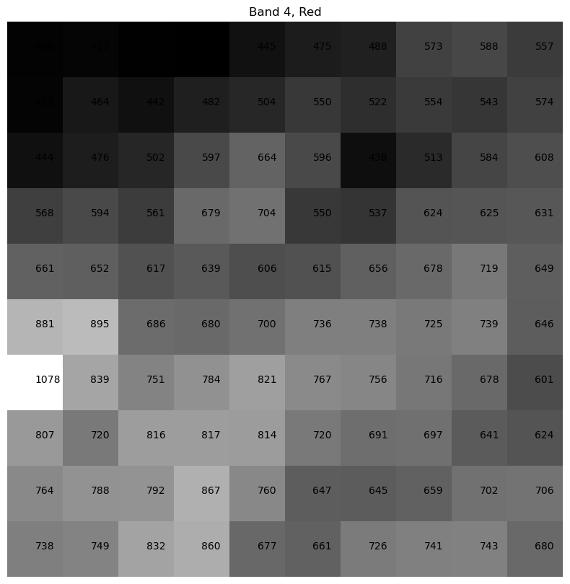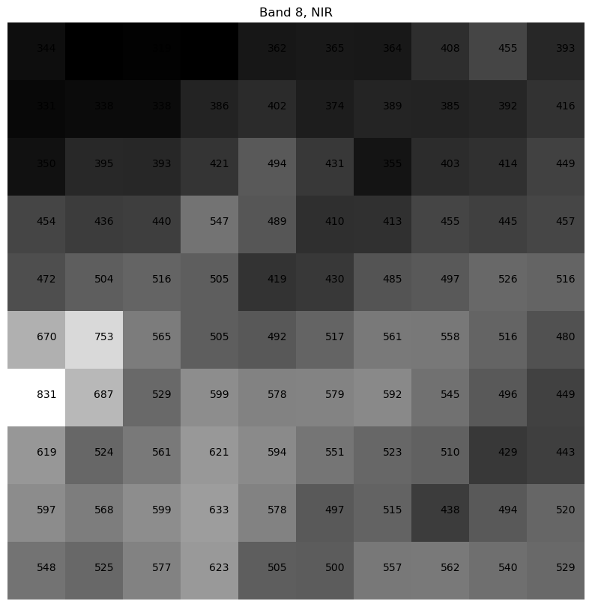

Image transformation – computation of Indices - NDVI, NDWI – zonation

import rasterio
import numpy as np
import matplotlib.pyplot as plt

# Load the image
file_path = r'E:\CTECH\GEOINT\project\SentinelTinkitamAPR2021.tif'
with rasterio.open(file_path) as src:
red = src.read(3)
nir = src.read(7)
profile = src.profile

# Calculate NDVI
ndvi = (nir - red) / (nir + red)

def classify_ndvi(ndvi):
zones = np.zeros_like(ndvi)
zones[ndvi <= 0.1] = 0
zones[(ndvi > 0.1)&(ndvi <= 0.2)] = 0
zones[(ndvi > 0.2)&(ndvi <= 0.3)] = 0
zones[(ndvi > 0.3)&(ndvi <= 0.4)] = 0
zones[(ndvi > 0.4)&(ndvi <= 0.5)] = 0
zones[(ndvi > 0.5)&(ndvi <= 0.6)] = 0
zones[(ndvi > 0.6)&(ndvi <= 0.7)] = 6
zones[(ndvi > 0.7)&(ndvi <= 0.8)] = 7
zones[(ndvi > 0.8)&(ndvi <= 0.9)] = 8
zones[(ndvi > 0.9)] = 9
return zones

# ndvi zone
ndvi_zones = classify_ndvi(ndvi)

# Plot the results
fig, ax = plt.subplots(1,2,figsize=(15, 10))

ax[0].imshow(ndvi, cmap='RdYlGn')
ax[0].set_title('NDVI')

ax[1].imshow(ndvi_zones, cmap='Greens')
ax[1].set_title('NDVI Zone')

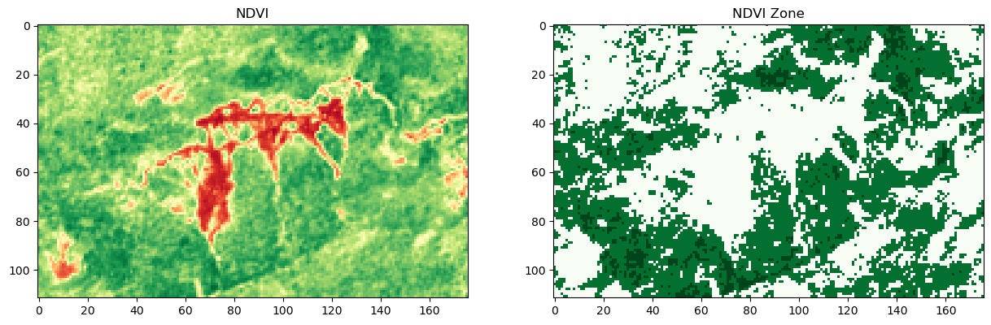

# Classification for Landslide

def classify_threshold_ndvi(ndvi):
zones = np.zeros_like(ndvi)
zones[ndvi <= 0.1] = 0
zones[(ndvi > 0.1)&(ndvi <= 0.2)] = 0
zones[(ndvi > 0.2)&(ndvi <= 0.3)] = 0
zones[(ndvi > 0.3)&(ndvi <= 0.4)] = 1
zones[(ndvi > 0.4)&(ndvi <= 0.5)] = 1
zones[(ndvi > 0.5)&(ndvi <= 0.6)] = 1
zones[(ndvi > 0.6)&(ndvi <= 0.7)] = 1
zones[(ndvi > 0.7)&(ndvi <= 0.8)] = 1
zones[(ndvi > 0.8)&(ndvi <= 0.9)] = 1
zones[(ndvi > 0.9)] = 1
return zones

# ndvi zone
ndvi_threshold_zones = classify_threshold_ndvi(ndvi)

classification=np.where(ndvi_threshold_zones,0,1)
class1=ndvi_threshold_zones==0
class2=ndvi_threshold_zones==1

# Plot the results
fig, ax = plt.subplots(1,2,figsize=(15, 10))

ax[0].imshow(class1, cmap='Oranges')
ax[0].set_title('Non-Vegetation')

ax[1].imshow(class2, cmap='Greens')
ax[1].set_title('Vegetation')

# NDVI Results

output_tiff_nonveg = r'E:\CTECH\GEOINT\project\Non-Vegetation.tiff'
with rasterio.open(output_tiff_nonveg, 'w', **profile) as dst:
dst.write(ndvi.astype(rasterio.uint8), 1)
# NDLI zone Results
output_tiff_veg = r'E:\CTECH\GEOINT\project\Vegetation.tiff'
with rasterio.open(output_tiff_veg, 'w', **profile) as dst:
dst.write(ndvi_zones.astype(rasterio.uint8), 1)

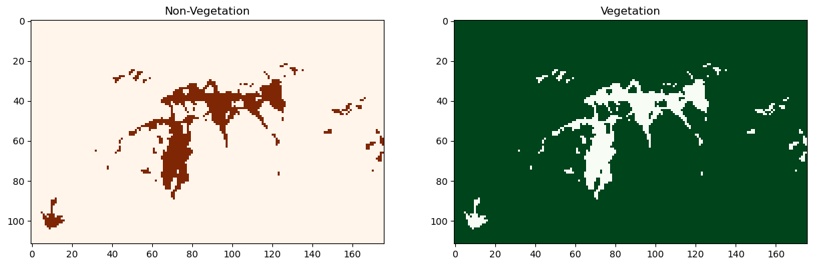

Convert raster to vector file format (.shp, .Geojson) based on specific features

import geopandas as gpd
import matplotlib.pyplot as plt
from rasterio.features import shapes

# Extract shapes (polygons) from the landslide raster
mask = class2.astype(np.uint8)
results = (
{'properties': {'raster_val': v}, 'geometry': s}
for i, (s, v)
in enumerate(shapes(mask, mask=mask, transform=src.transform))
)
# Convert the shapes to a GeoDataFrame
geoms = list(results)
gdf1 = gpd.GeoDataFrame.from_features(geoms, crs=src.crs)

# Save the GeoDataFrame as a shapefile
output_shapefile = "Non -Vegetation.shp"
gdf1.to_file(output_shapefile)

#------------------------------------------------------------------------------
# Extract shapes (polygons) from the landslide raster
mask = class1.astype(np.uint8)
results = (
{'properties': {'raster_val': v}, 'geometry': s}
for i, (s, v)
in enumerate(shapes(mask, mask=mask, transform=src.transform))
)
# Convert the shapes to a GeoDataFrame
geoms = list(results)
gdf2 = gpd.GeoDataFrame.from_features(geoms, crs=src.crs)

# Save the GeoDataFrame as a shapefile
output_shapefile = 'Vegetation.shp'
gdf2.to_file(output_shapefile)

#-------------------------------------------------------------------------------
# Plot the results
fig, ax = plt.subplots(1,1, figsize=(20,5))
gdf2.boundary.plot(ax=ax, edgecolor='black',linewidth=1)
plt.title('Non-Vegetation')
plt.show()

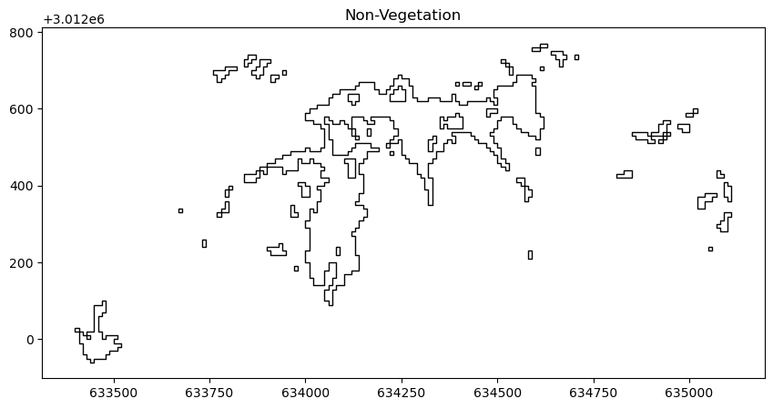
import geopandas as gpd

# Define the input shapefile path and the output GeoJSON file path
shapefile_path = "E:\CTECH\GEOINT\project\Vegetation.shp"

# Load the shapefile using GeoPandas
gdf = gpd.read_file(shapefile_path)

# Convert the GeoDataFrame to GeoJSON and save it to a file
geojson_path = 'SentinelTinkitamDEC2020_LANDSLIDE.geojson'
gdf.to_file(geojson_path, driver='GeoJSON')

<>:4: SyntaxWarning: invalid escape sequence '\C'
<>:4: SyntaxWarning: invalid escape sequence '\C'
C:\Users\ghosh\AppData\Local\Temp\ipykernel_8516\2947162551.py:4: SyntaxWarning: invalid escape sequence '\C'
shapefile_path = "E:\CTECH\GEOINT\project\Vegetation.shp"

Image classification – Supervised & Unsupervised – zonation

import rasterio
import numpy as np
import matplotlib.pyplot as plt
from sklearn.cluster import KMeans

# Step 1: Open the image using rasterio
with rasterio.open(r'E:\CTECH\GEOINT\project\SentinelTinkitamAPR2021.tif') as src:
img = src.read([1,2])
profile = src.profile
# Transpose to get the shape (height, width, bands)
img = np.transpose(img, (1, 2, 0))

# Step 2: Reshape the image to a 2D array of pixels
n_bands = img.shape[2]
n_rows = img.shape[0]
n_cols = img.shape[1]
pixels = img.reshape((n_rows * n_cols, n_bands))

# Step 3: Perform K-means clustering
n_clusters = 5 # Number of clusters (classes)
kmeans = KMeans(n_clusters=n_clusters, random_state=42)
kmeans.fit(pixels)

# Step 4: Assign each pixel to a cluster
classified_pixels = kmeans.labels_
classified_img = classified_pixels.reshape((n_rows, n_cols))

# Step 5: Plot the classified image
plt.figure(figsize=(10, 10))
plt.imshow(classified_img, cmap='viridis')
# plt.imshow(classified_img, cmap='gray')
plt.title(f'Classified Image with {n_clusters} clusters')
plt.show()

# NDLI Results
output_tiff_classify = 'Unsupervised.tiff'
with rasterio.open(output_tiff_classify, 'w', **profile) as dst:
dst.write(classified_img.astype(rasterio.uint8), 1)

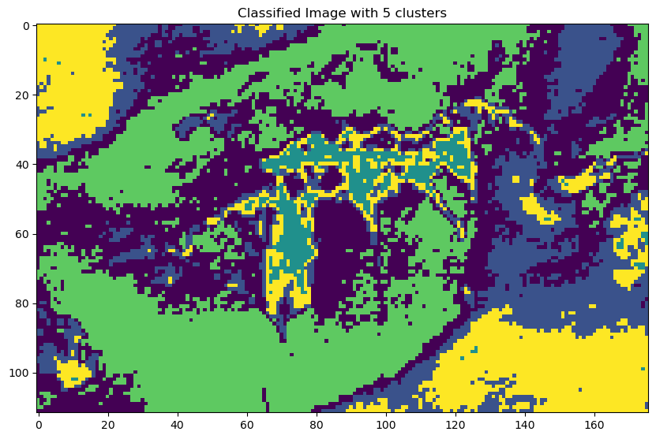

import rasterio

image_path = r'E:\CTECH\GEOINT\project\SentinelTinkitamAPR2021.tif'
with rasterio.open(image_path) as src:
band1 = src.read(1) # Read the first band
pixel_value = band1[10, 10] # Access the pixel value at (10, 10)
print(f"Pixel value at (10, 10): {pixel_value}")

Pixel value at (10, 10): 807

import matplotlib.pyplot as plt

with rasterio.open(image_path) as src:
img = src.read(1) # Read the first band
plt.figure(figsize=(10, 10))
plt.imshow(img, cmap='gray')
plt.scatter(110, 60, c='red', label='(10, 10)') #x,y
plt.scatter(112, 65, c='green', label='(10, 10)') #x,y
plt.legend()
plt.title('Image with Coordinate')
plt.show()

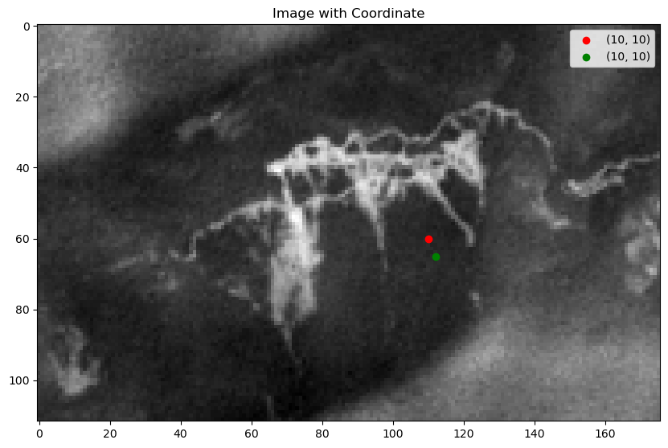

import rasterio
import numpy as np
from sklearn.ensemble import RandomForestClassifier
from sklearn.model_selection import train_test_split
from sklearn.metrics import classification_report
import matplotlib.pyplot as plt

# Load Sentinel-2 image
def load_image(image_path):
with rasterio.open(image_path) as src:
bands = [src.read(i) for i in range(1, src.count + 1)]
profile = src.profile
return np.stack(bands, axis=-1), profile

# Extract training samples
def extract_samples(image, training_data, num_bands):
samples = []
labels = []
for label, coords in training_data.items():
for coord in coords:
x, y = coord
sample = image[y, x, :]
samples.append(sample)
labels.append(label)
return np.array(samples), np.array(labels)

# Load image
image_path = r'E:\CTECH\GEOINT\project\SentinelTinkitamAPR2021.tif'
image, profile = load_image(image_path)

# Define training data (for example purposes, this should be replaced with actual coordinates and labels)
training_data = {
1: [(70, 60), (70, 65), (71,64)], # Class 1
2: [(110, 60), (112, 65),(112,70)], # Class 2

}

# Extract samples and labels
num_bands = image.shape[2]
samples, labels = extract_samples(image, training_data, num_bands)

# Split data into training and test sets
X_train, X_test, y_train, y_test = train_test_split(samples, labels, test_size=0.3, random_state=42)

# Train classifier
clf = RandomForestClassifier(n_estimators=100, random_state=42)
clf.fit(X_train, y_train)

# Predict on the entire image
def classify_image(image, classifier):
height, width, num_bands = image.shape
flat_image = image.reshape(-1, num_bands)
flat_prediction = classifier.predict(flat_image)
return flat_prediction.reshape(height, width)

classified_image = classify_image(image, clf)

# Display results
plt.figure(figsize=(10, 10))
plt.imshow(classified_image, cmap='viridis')
#plt.colorbar()
plt.title('Classified Image')
plt.show()

# Save classified image
output_path = 'classified_image.tif'
with rasterio.open(output_path, 'w', driver='GTiff', height=image.shape[0], width=image.shape[1],
count=1, dtype=classified_image.dtype, crs=profile['crs'], transform=profile['transform']) as dst:
dst.write(classified_image, 1)

print("Classification completed and saved to", output_path)

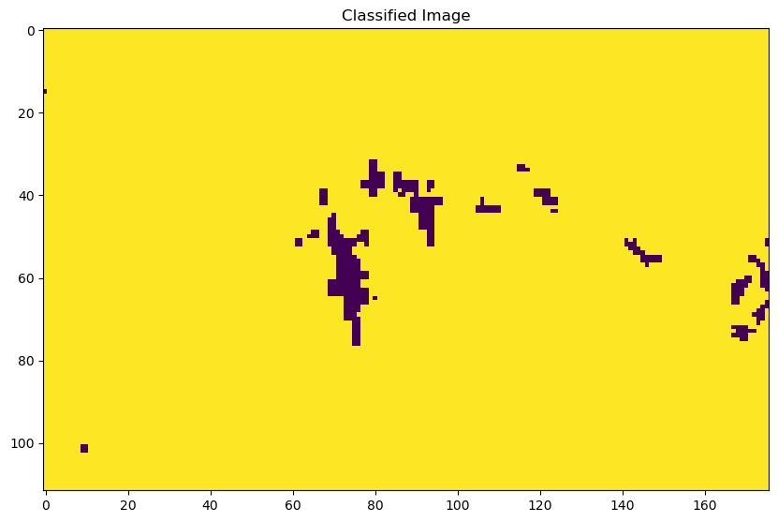

import geopandas as gpd
import matplotlib.pyplot as plt
from rasterio.features import shapes

# Extract shapes (polygons) from the landslide raster
mask = classified_img.astype(np.uint8)
results = (
{'properties': {'raster_val': v}, 'geometry': s}
for i, (s, v)
in enumerate(shapes(mask, mask=mask, transform=src.transform))
)
# Convert the shapes to a GeoDataFrame
geoms = list(results)
gdf_Uclass = gpd.GeoDataFrame.from_features(geoms, crs=src.crs)

# Save the GeoDataFrame as a shapefile
output_shapefile = 'Uclassification.shp'
gdf_Uclass.to_file(output_shapefile)

#------------------------------------------------------------------------------
# Plot the results
fig, ax = plt.subplots(1,1, figsize=(20,5))
gdf_Uclass.boundary.plot(ax=ax, edgecolor='black',linewidth=1)
plt.title('Zone')
plt.show()

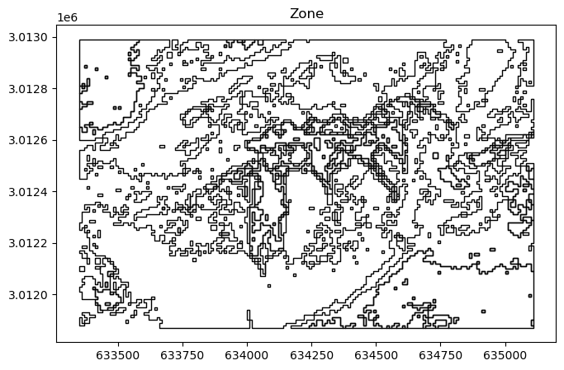

#Classification and assign name

import geopandas as gpd
import os

# Directory paths
input_dir = "E:\CTECH\GEOINT\project"
output_dir = "E:\CTECH\GEOINT\project"
os.makedirs(output_dir, exist_ok=True)

# List of shapefiles
shapefiles = [
'Uclassification.shp'
]

# Function to set RegionName based on raster_val
def set_region_name(row):
if row['raster_val'] == 1:
return 'Landslide : Dry mixed soil and rock debris'
elif row['raster_val'] == 2:
return 'Landslide : Wet soil debris'
elif row['raster_val'] == 3:
return 'Vegetation: Shrubland'
elif row['raster_val'] == 4:
return 'Vegetation: Forest area'
elif row['raster_val'] == 5:
return 'Fallow land: Wet eroded soil'
else:
return 'Unknown'

# Process each shapefile
for shp in shapefiles:
# Read shapefile
filepath = os.path.join(input_dir, shp)
gdf = gpd.read_file(filepath)

# Add 'RegionName' column based on 'raster_val'
gdf['RegionName'] = gdf.apply(set_region_name, axis=1)

# Save the modified shapefile
output_filepath = os.path.join(output_dir, shp)
gdf.to_file(output_filepath)

